Rafid = Red

Ratun = Blue

Akib = Green

Rafsan = Purple

**Introduction** **2**

Why we choose the game 2

Which method are we using & why 2

Aim of the paper 2

What's in this paper 2

**Literature Review** **2**

**Methodology** **3**

Analysis Phase 3

Concept Design Phase 3

Implementation Phase 3

Evaluation Phase 3

**Implementation** **3**

Sensor Based Tracking 3

Developing the prototype 3

Create Graphics 3

Environment 3

**Result And Evaluation** **3**

User Acceptance Testing 3

Usability Testing 3

**Conclusion** **4** **4**

NFS: A Hand Gesture Recognition Based Game Using Allah Jane Ki

| Md. Rafid Islam  Software Engineering  Islamic University of Technology  Gazipur, Dhaka, Bangladesh | Ratun Rahman  Software Engineering  Islamic University of Technology  Gazipur, Dhaka, Bangladesh | Akib Ahmed  Software Engineering  Islamic University of Technology  Gazipur, Dhaka, Bangladesh | Rafsan Jany  Software Engineering  Islamic University of Technology  Gazipur, Dhaka, Bangladesh |
| --- | --- | --- | --- |

***Abstract—***

***Keywords-***

# Introduction

## Why we choose the game

## Which method are we using & why

## Aim of the paper

## What's in this paper

# Literature Review

What is the game and how to play the game

What is our method and how it works

# Methodology

## Analysis Phase

## Concept Design Phase

## Implementation Phase

## Evaluation Phase

# Implementation

## Sensor Based Tracking

## Developing the prototype

## Create Graphics

## Environment

# Result And Evaluation

## User Acceptance Testing

| **Events** | **Expected Results** | **Actual Results** |
| --- | --- | --- |
| Detect Hand Gesture | Hand gesture will be recognized and work smoothly | Hand gesture recognition is working fine |
| Move Car | Swiping hand towards a direction will work as a command to move the vehicle | The vehicle movement is working perfectly and precisely |
| Have Game Mechanics | Game will start and will end when the vehicle crush with other vehicle | There is no start menu and the game restart automatically after crush |

## Usability Testing

Difficulties to use

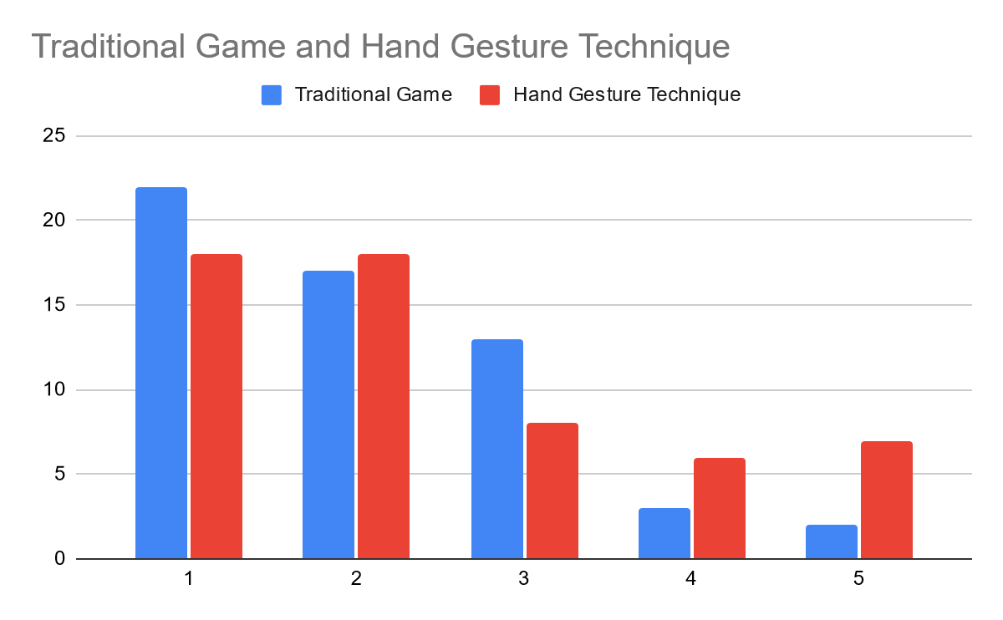

Fun elements

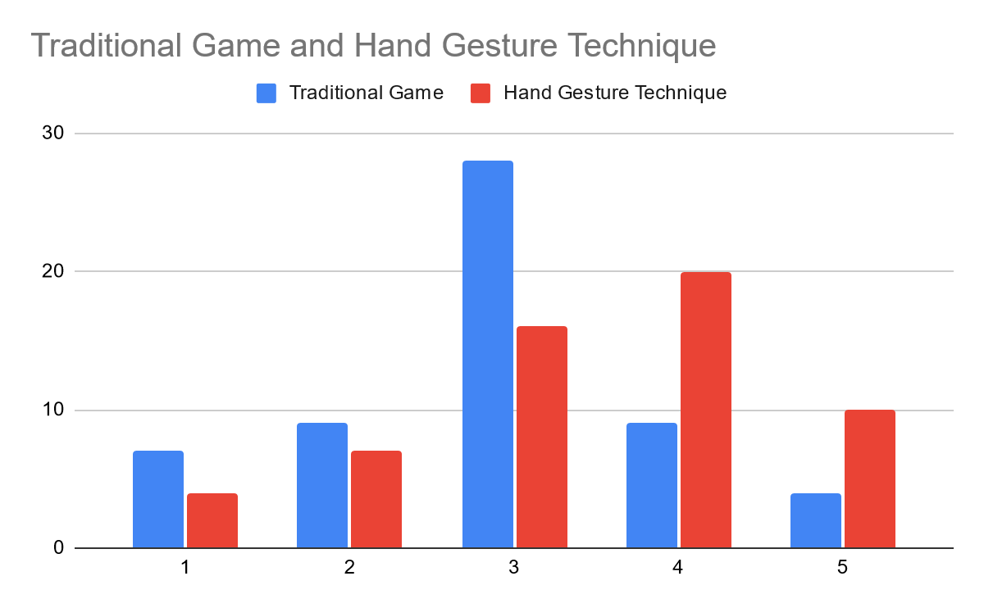

Gameplay

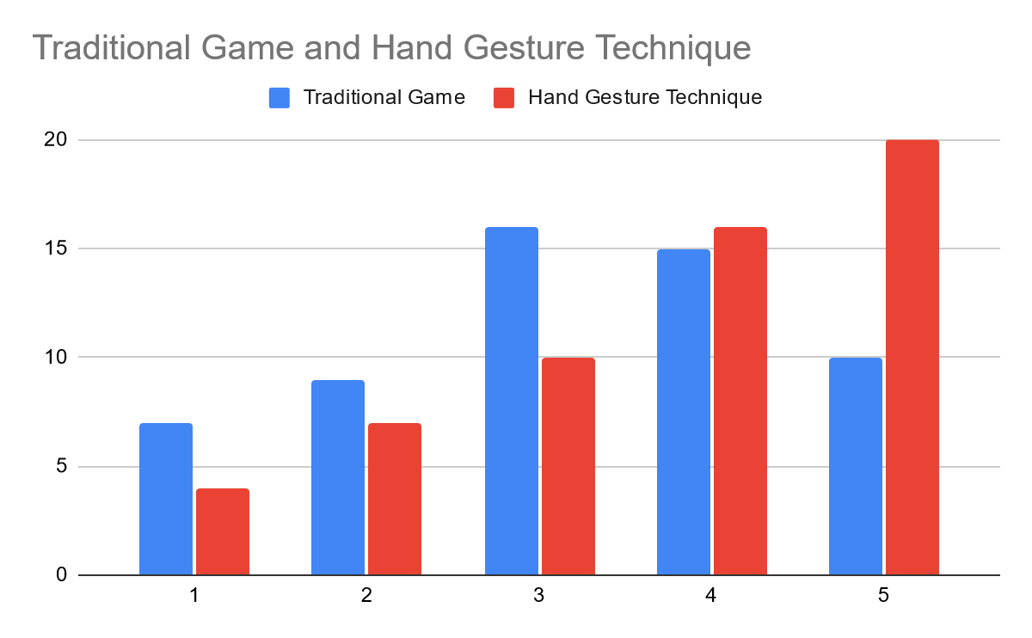

Replayability

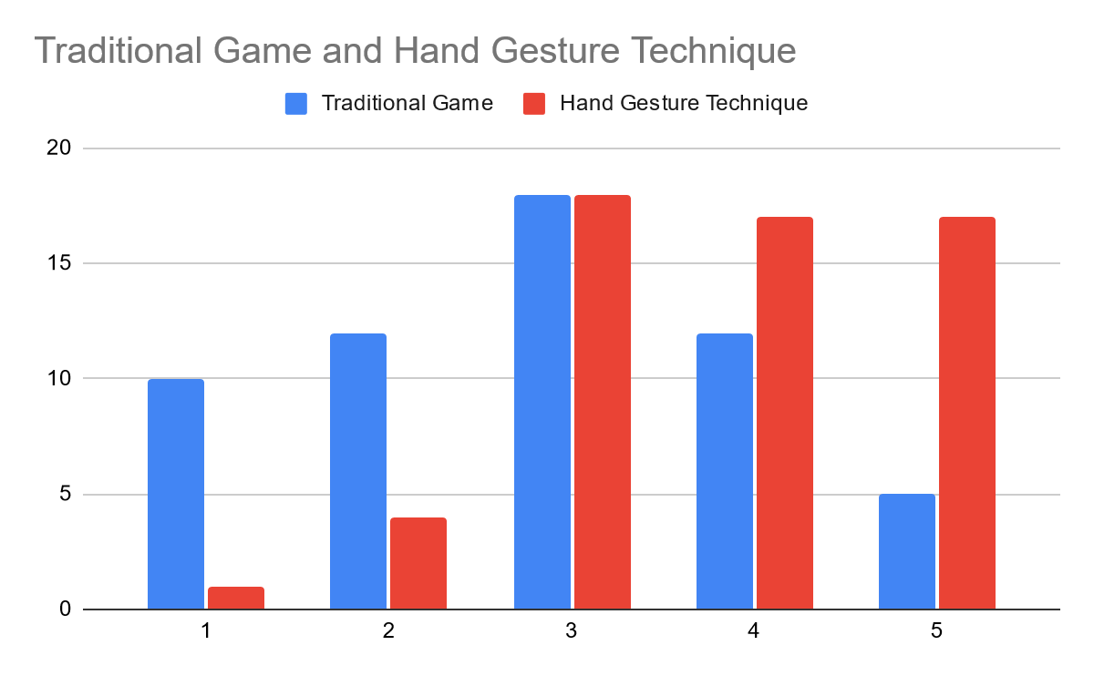

# Conclusion

Make it better quality (3D)

Add sound effects

Main menu and interfaces

Complex and other games

# References

1. Khan, R.Z. and Ibraheem, N.A., 2012. Hand gesture recognition: a literature review. *International journal of artificial Intelligence & Applications*, *3*(4), p.161.
2. Fang, Y., Wang, K., Cheng, J. and Lu, H., 2007, July. A real-time hand gesture recognition method. In *2007 IEEE International Conference on Multimedia and Expo* (pp. 995-998). IEEE.
3. Rautaray, S.S. and Agrawal, A., 2011, December. Interaction with virtual game through hand gesture recognition. In *2011 International Conference on Multimedia, Signal Processing and Communication Technologies* (pp. 244-247). IEEE.
4. Zhang, X., Chen, X., Li, Y., Lantz, V., Wang, K. and Yang, J., 2011. A framework for hand gesture recognition based on accelerometer and EMG sensors. *IEEE Transactions on Systems, Man, and Cybernetics-Part A: Systems and Humans*, *41*(6), pp.1064-1076.
5. Garan, T.A. and Suaib, N.M., Hand Gesture Integration of 3D Virtual Rubik’s Cube Using Leap Motion.